Capitol Hill Restoration Society
Emerald Street, NE Historic Walking Tour
September 11 & October 8, 2016

Meet at the corner of 13th and Emerald Streets, NE
Topics: Why a building boom on Emerald Street in 1892?
DC economy, growth of middle class, demand for housing, land speculation
William Mayse and Louis D. Wine: before and after maps of Square 1029
Francis S. Carmody: 511-517 13th Street, NE, 1307 Emerald Street, NE (1895); map showing builders

Stop 2:
Walk east on Emerald Street to 1306 Emerald Street, NE, Queen Anne. George P. Newton (owner, architect, builder) (1892)
Topics: brick coursing; running bond (aka stretcher bond), press brick (blind bonding), Queen Anne rowhouses, chamfered bays, ornament
Demographic note: 1900 census

Stop 3.
Walk east on Emerald Street to 1339 Emerald Street, Queen Anne. owner: Watson J. Newton; builder: George P. Newton, architect: C.B.F. Haller (1895)
Topics: Watson J. Newton, attorney/law professor, real estate investor.
Topic: Emerson Street to Emerald Street.

Stop 4:
Walk east on Emerald Street to 1353-1355 Emerald Street, NE, Queen Anne. George P. Newton (owner, architect, builder) (1896)
Topics: George P. Newton, real estate business, master builders in DC. map showing builders, 1968 riots on H Street, NE and Urban Renewal.

Stop 5.
Walk east on Emerald Street, then south on 14th Street, then west on E Street to 1368-1372 E Street, NE, Classical Revival. George P. Newton (owner/builder), N.T. Haller, architect (1905)
Topics: World's Columbian Exposition, Chicago (1892), Classical Revival houses. NT Haller sketch for building permit, and details on building these houses.

Stop 6.
Walk west on E Street to 1330 E Street, NE, daylighters porch-front house. (1932)
Topic: Lewis Wentworth Giles, architect; demand for Craftsman-influenced bungalows; American bond brick coursing with raked joint. Thomas A. Jameson porch-front rowhouses across E Street and at 519-525 13th Street, NE (1923).

End of tour

For additional information see www.chrs.org or call 202 543-0425
Architects, speculators, and builders

Francis S. Carmody, builder (1868-1921) was a general contractor who built a number of apartments and houses in Washington. He advertised a specialization in foundations. He lived in Seat Pleasant, Md. and was active in Maryland politics. In 1895 Carmody divided four lots at the corner of 13th and Emerson streets (lots 69 to 72) to create five lots (lots 197 to 201).

Lewis Wentworth Giles, architect (1894-1974). Giles was a well-known African-American architect who graduated from Armstrong Technical and studied architecture at the University of Illinois. After serving in World War I, he worked in the office of Isaiah Hatton from 1918 to 1921. In 1921, he opened his own office at 1200 U Street, NW. He designed many churches (Rock Creek Baptist Church, 4201 Eighth Street, NW; New Mt. Olive Baptist Church, Fifty-eighth and Grant Streets, NE), offices, apartment buildings and houses in Capitol Hill, Brookland, Eastland Gardens, Capitol View and Deanwood. Later, his home and office was at 4428 Hunt Place, NE, a house that he designed.

Colen Bernard Ferguson (C.B.F.) Haller, architect (1864-1930), who held himself out as an interior designer, designed the houses at 1331-1351 Emerald Street (1895).

Nicholas T. Haller, (1855 -1917) architect, designed several notable buildings in Washington: the Warder Building (527 9th Street, six stories, brick with arcaded base, horizontally banded upper floors, Romanesque Revival detail, 1892), an early elevator building for B.H. Warder, a wealthy Ohio manufacturer of farm implements, who moved to Washington to invest in real estate; intended for use as offices, apartments, and stores. Haller's office was in this building. The Luzon (The Westover) (2501 Pennsylvania Avenue, NW, 1896 a prominently-situated Romanesque Revival apartment). The Lorraine, 1706 S Street NW, 1897. The Alice (The Sagamore), 1824 S Street, NW (1903). The American Theater, 102-106 Rhode Island Avenue, NW (1913). Haller designed expensive houses for several clients, including a highly ornamented brick and house on K Street, NW (1887, estimated cost: $5,000), a four-story house at 16th and L streets, NW (1888), a ten-room house in Washington Heights (1894). Six five-story limestone and brick residences at 22nd and Q streets, NW ($10,000 each, 1896). Haller also designed many rowhouses for many different owners across the city, including in LeDroit Park between 1884 and 1896.

Thomas A. Jameson, builder (1884-1932) started out as a carpenter’s apprentice in 1905. He began his career as a builder in Washington, DC in 1913 with the construction of eight row houses at 611-625 4th Street, NE. Over the next 15 years Jameson constructed almost 900 buildings, initially serving as the architect for his own development projects. His motto was "Ask the man who owns one." In 1923, he founded his own real estate company which, in addition to construction and sales, offered general real estate loans and insurance for moderate-income buyers and renters. Jameson often relied on architects L.T. Williams or George T. Santmyers, although he designed some buildings himself. Jameson's rowhouses were generally Craftsman-influenced beige brick porch-front houses, two rooms deep, with a rear porch, a sloping slate mansard roof and shed dormer. The houses Santmyers designed for Jameson at 519-523 13th Street, NE (1923) are typical Jameson rowhouses, and similar to Jameson's other houses nearby in square 1030.

William Mayse, real estate businessman. (1836-1911) He served as a captain in an Ohio regiment during the Civil War, and was working as a government clerk in Washington as of 1870. He bought and sold many properties in the late nineteenth century, served as President of the financial firm William Mayse & Co., and also as an officer in an investment company and a streetcar company. He was active in the Grand Army of the Republic, served on a committee of the East Washington Citizens Association, and helped to found a mutual aid organization for government clerks who lost their jobs.

George P. Newton, builder/architect (1865-1945) was from London, England, finished high school, and emigrated to the United States in 1885, and was living in Washington by 1887. That year he began buying land, building and selling houses. He was successful, drove a Cadillac runabout, participated in real estate organizations and temperance societies, and was noted in the society column of the Washington Star; he and his family vacationed in Atlantic City and Ocean City. Between 1897 and 1906 Newton built and between 400 and 500 houses. He went bankrupt in 1906, but continued to build houses for others.

Louis D. Wine, real estate businessman. (1838-1905) worked with the quartermaster's department during the Civil War, and afterwards entered the dry goods business. In 1887, he started a real estate business, and was well-known and active in civic affairs.

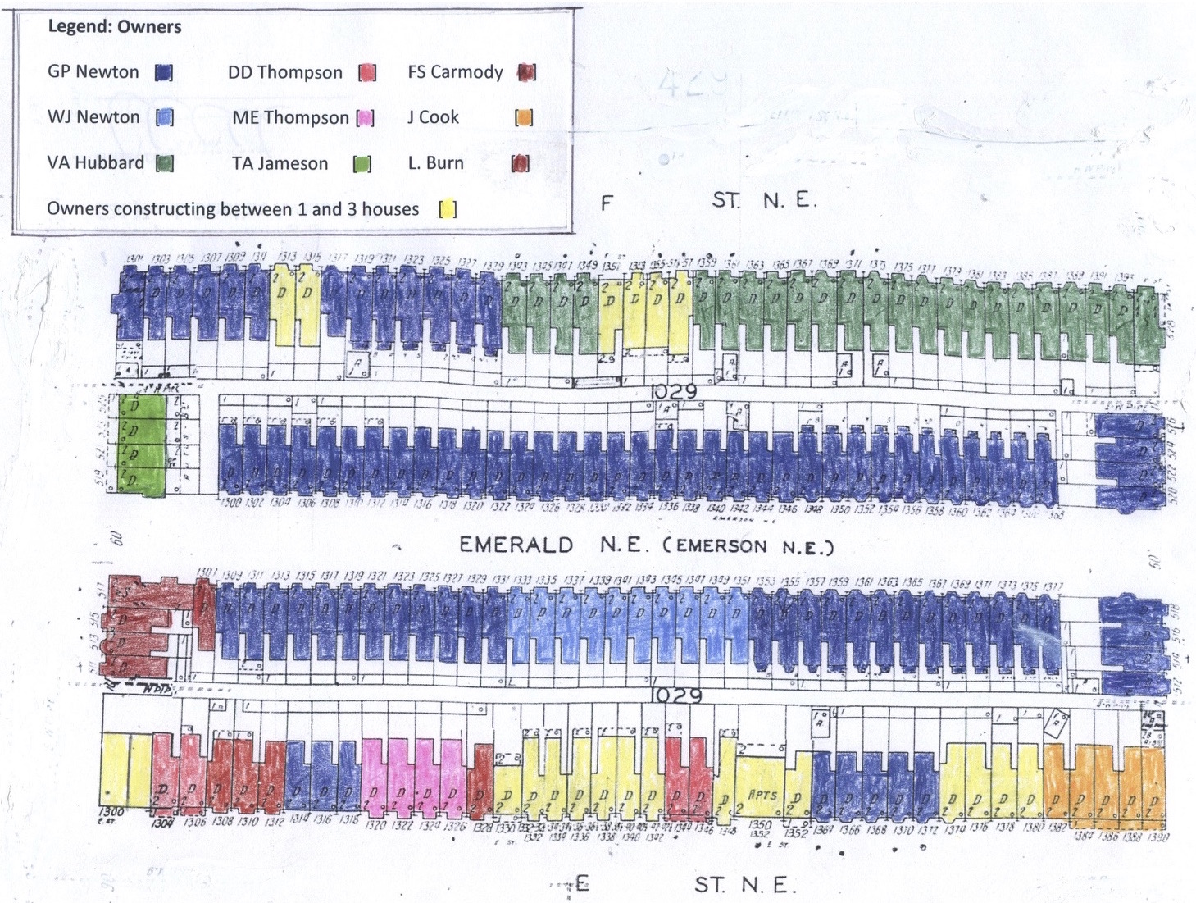

Map of Emerald Street builders

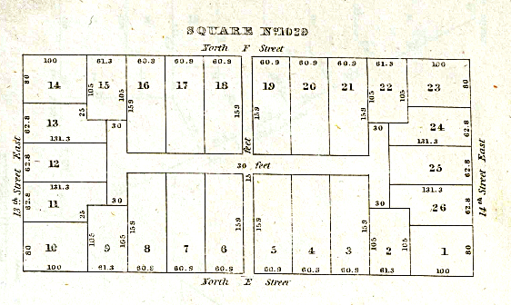
1797 map of square 1029

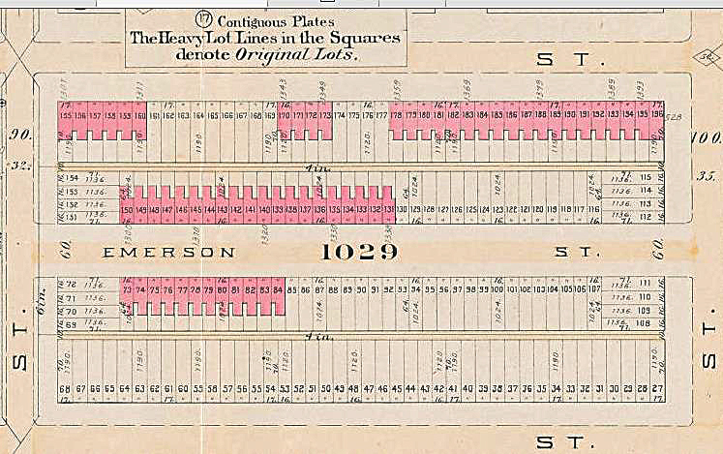
1893 Hopkins DC Atlas square 1029

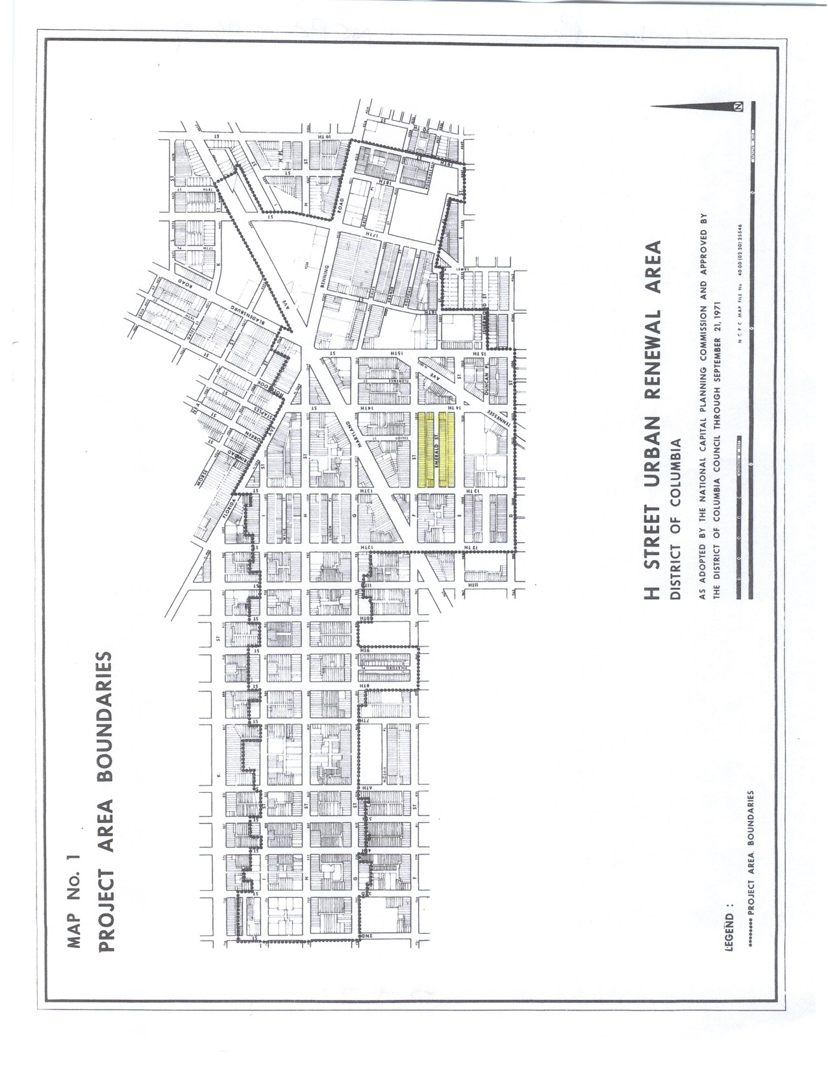
Map of H Street Urban Renewal Area (1971) showing Emerald Street

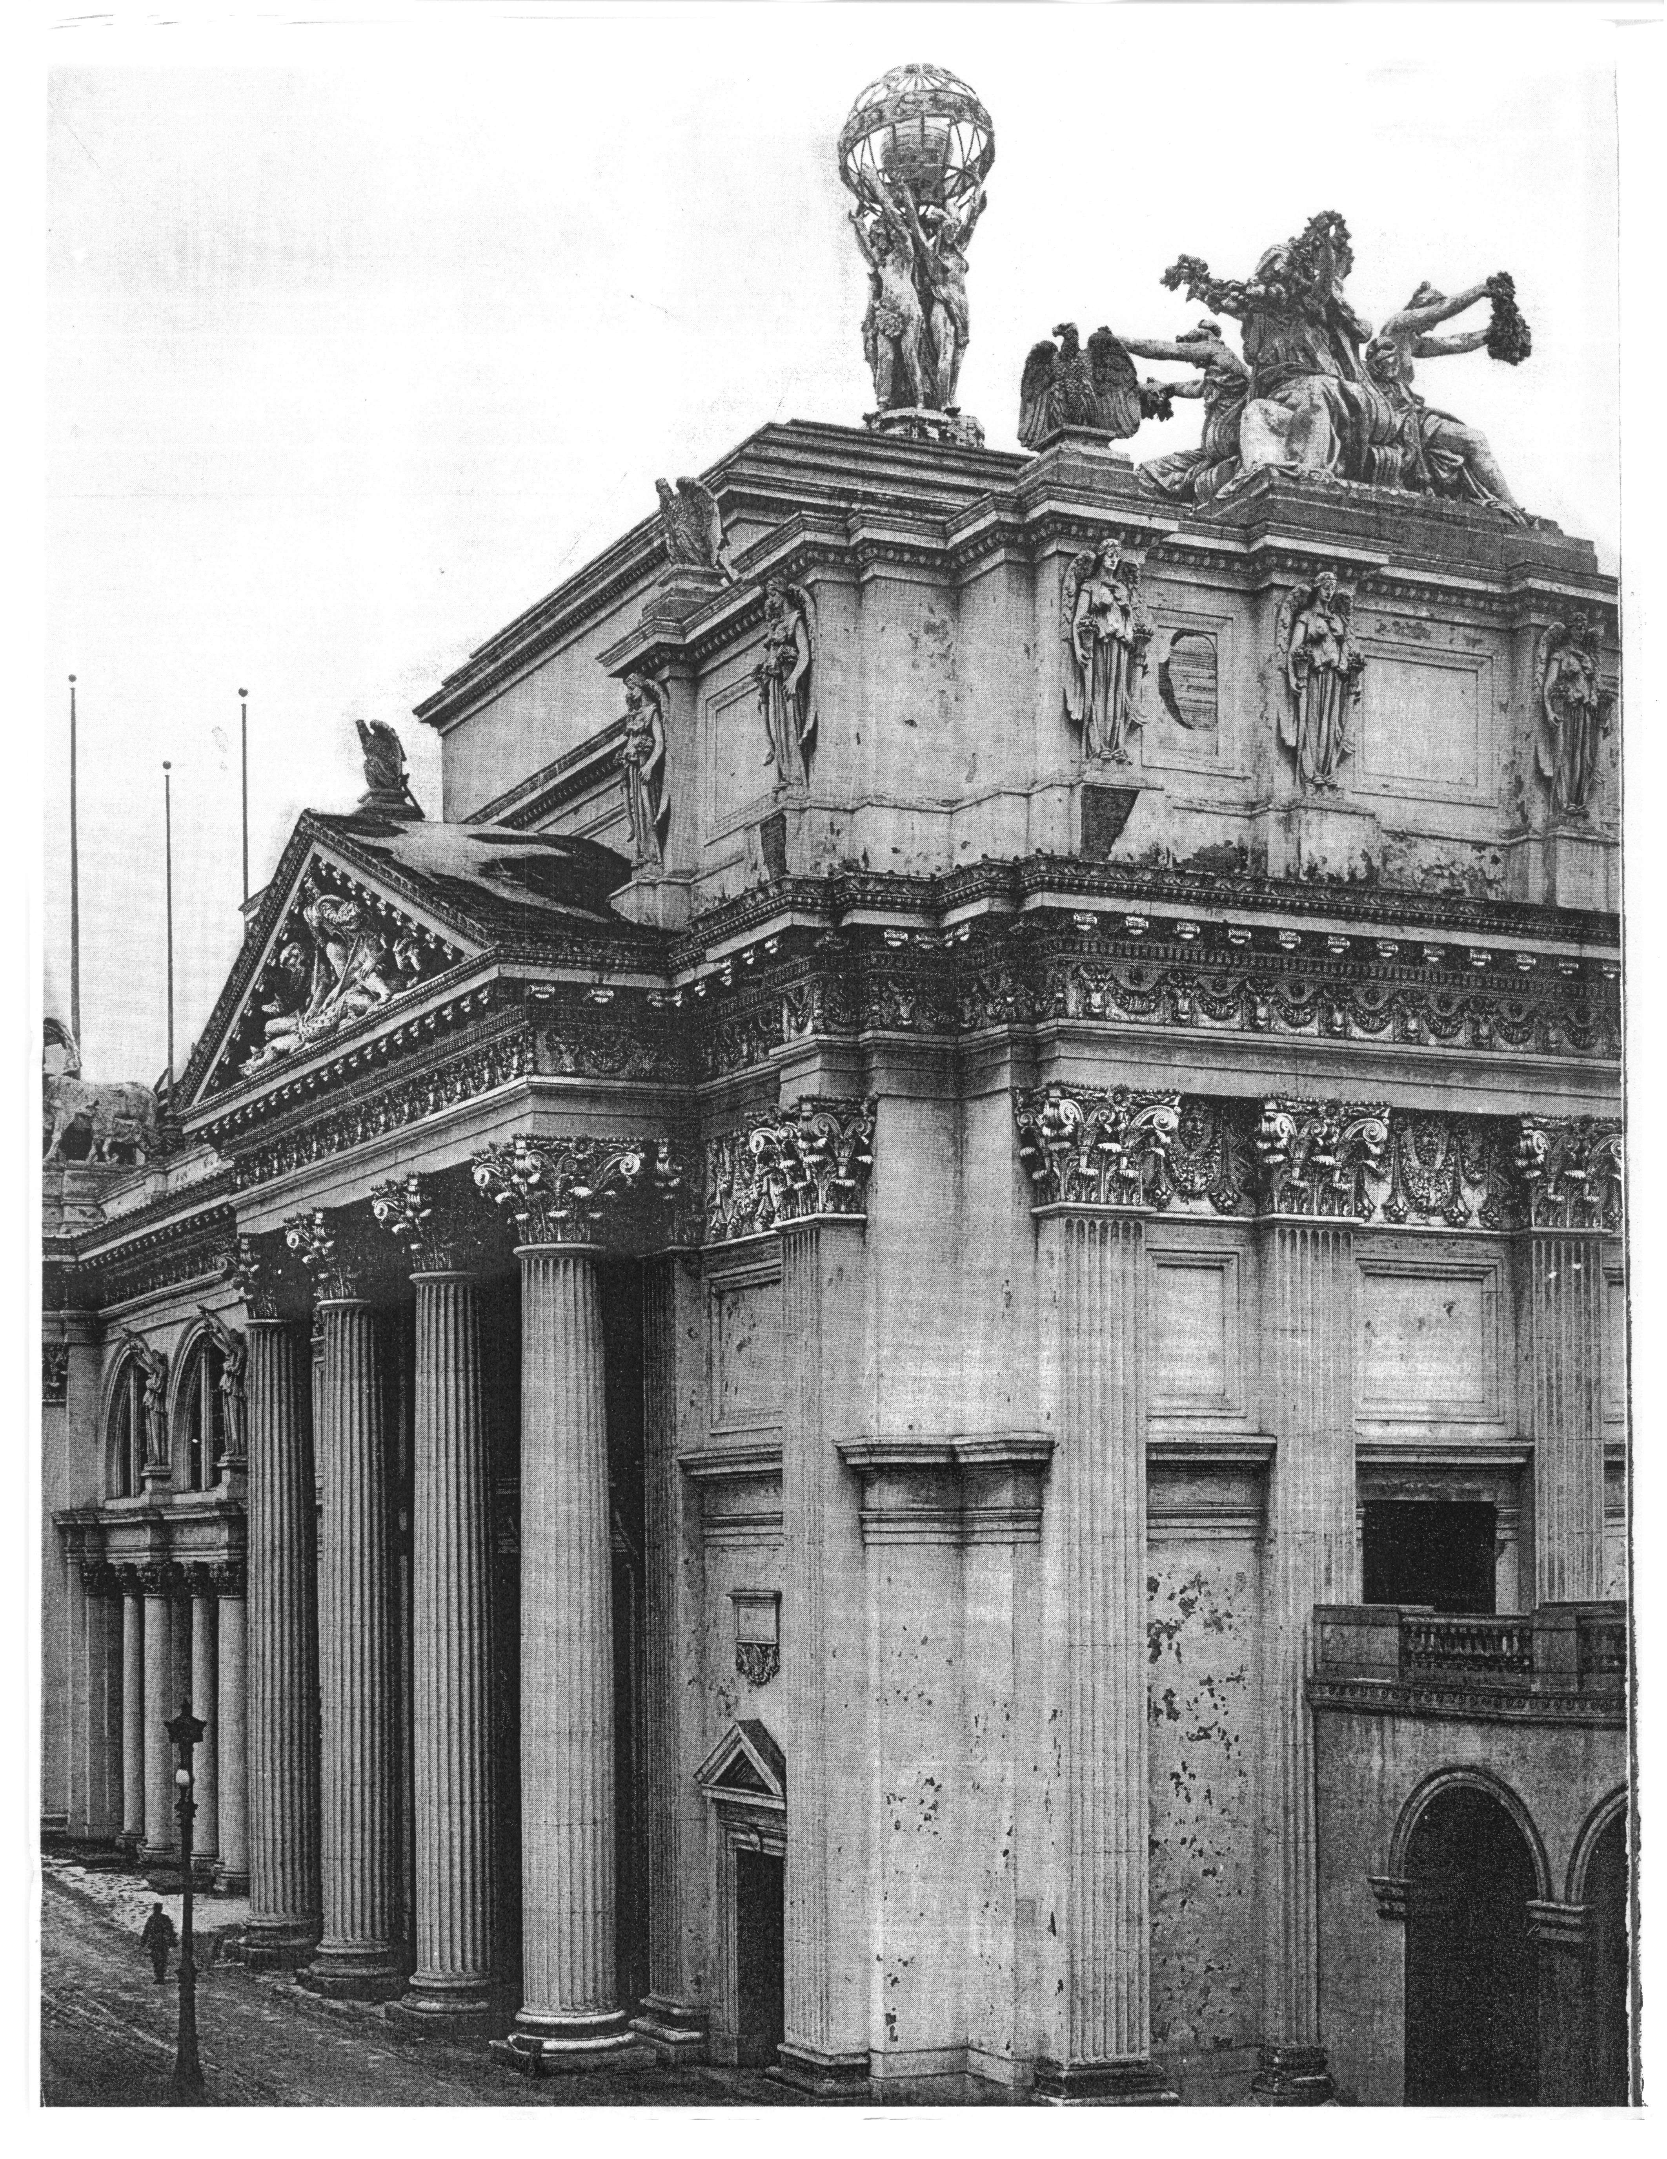
World Columbian Exposition

Typical Brick Coursing, from HPO publication, "Walls and Foundations of Historic Buildings"

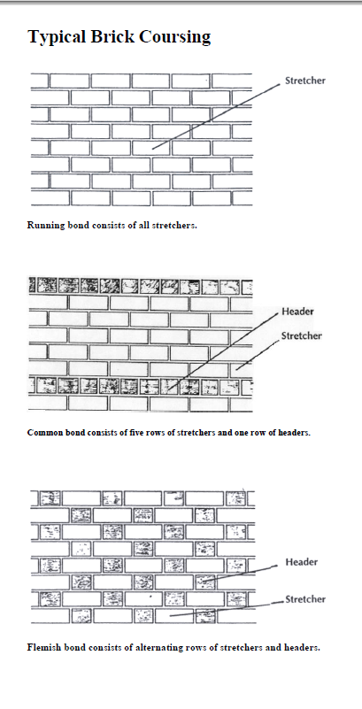

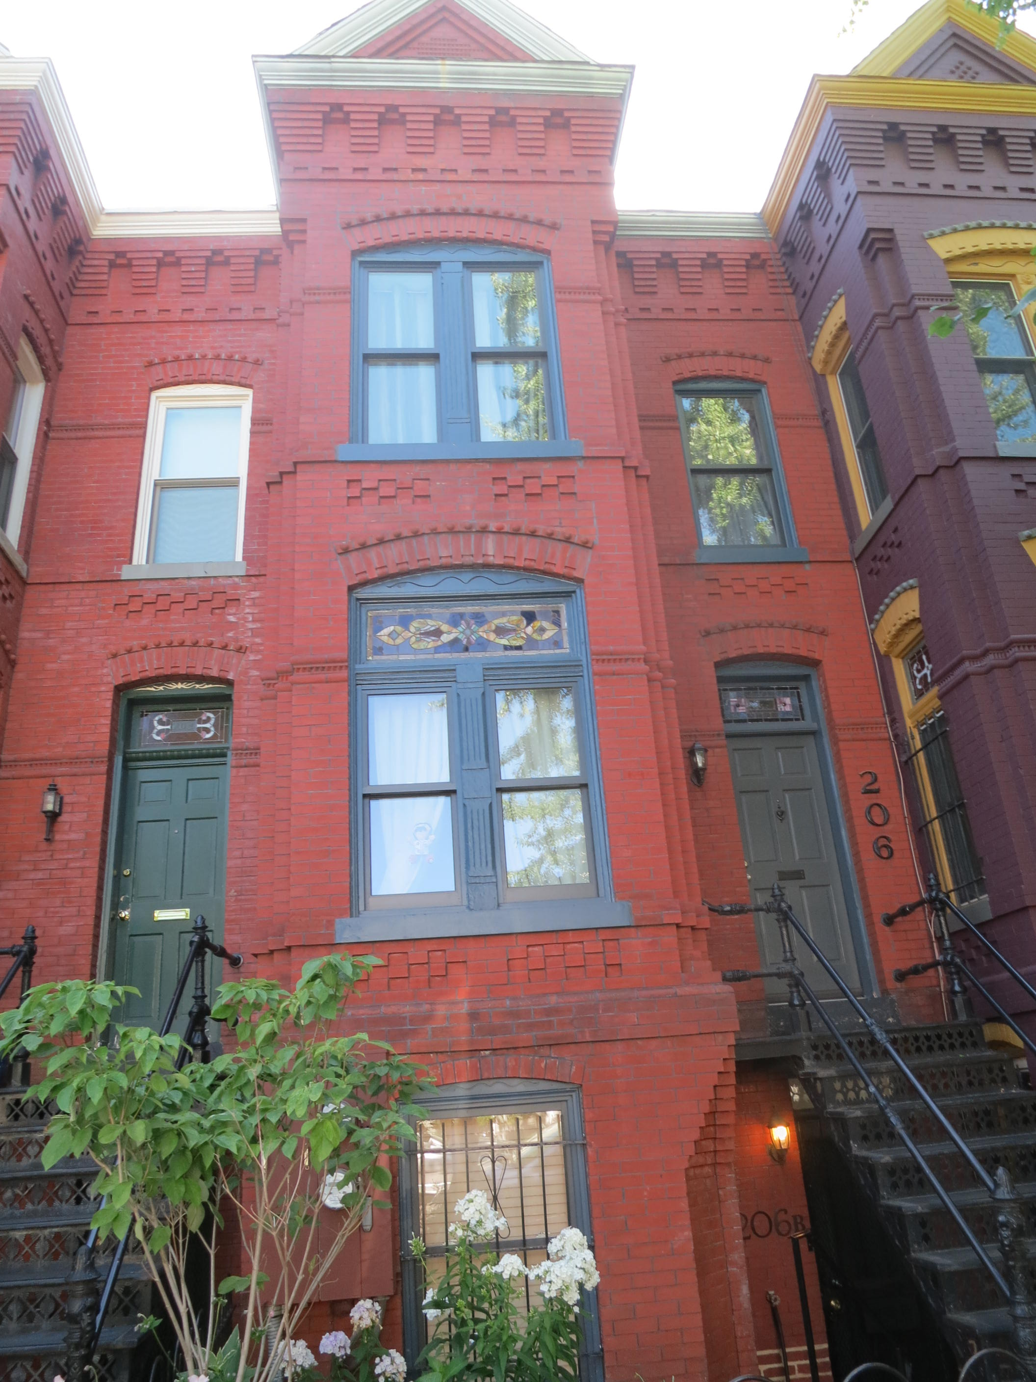 Charles Gessford's Queen Anne house at 206 10th Street, SE (1891); estimated cost: $10,000

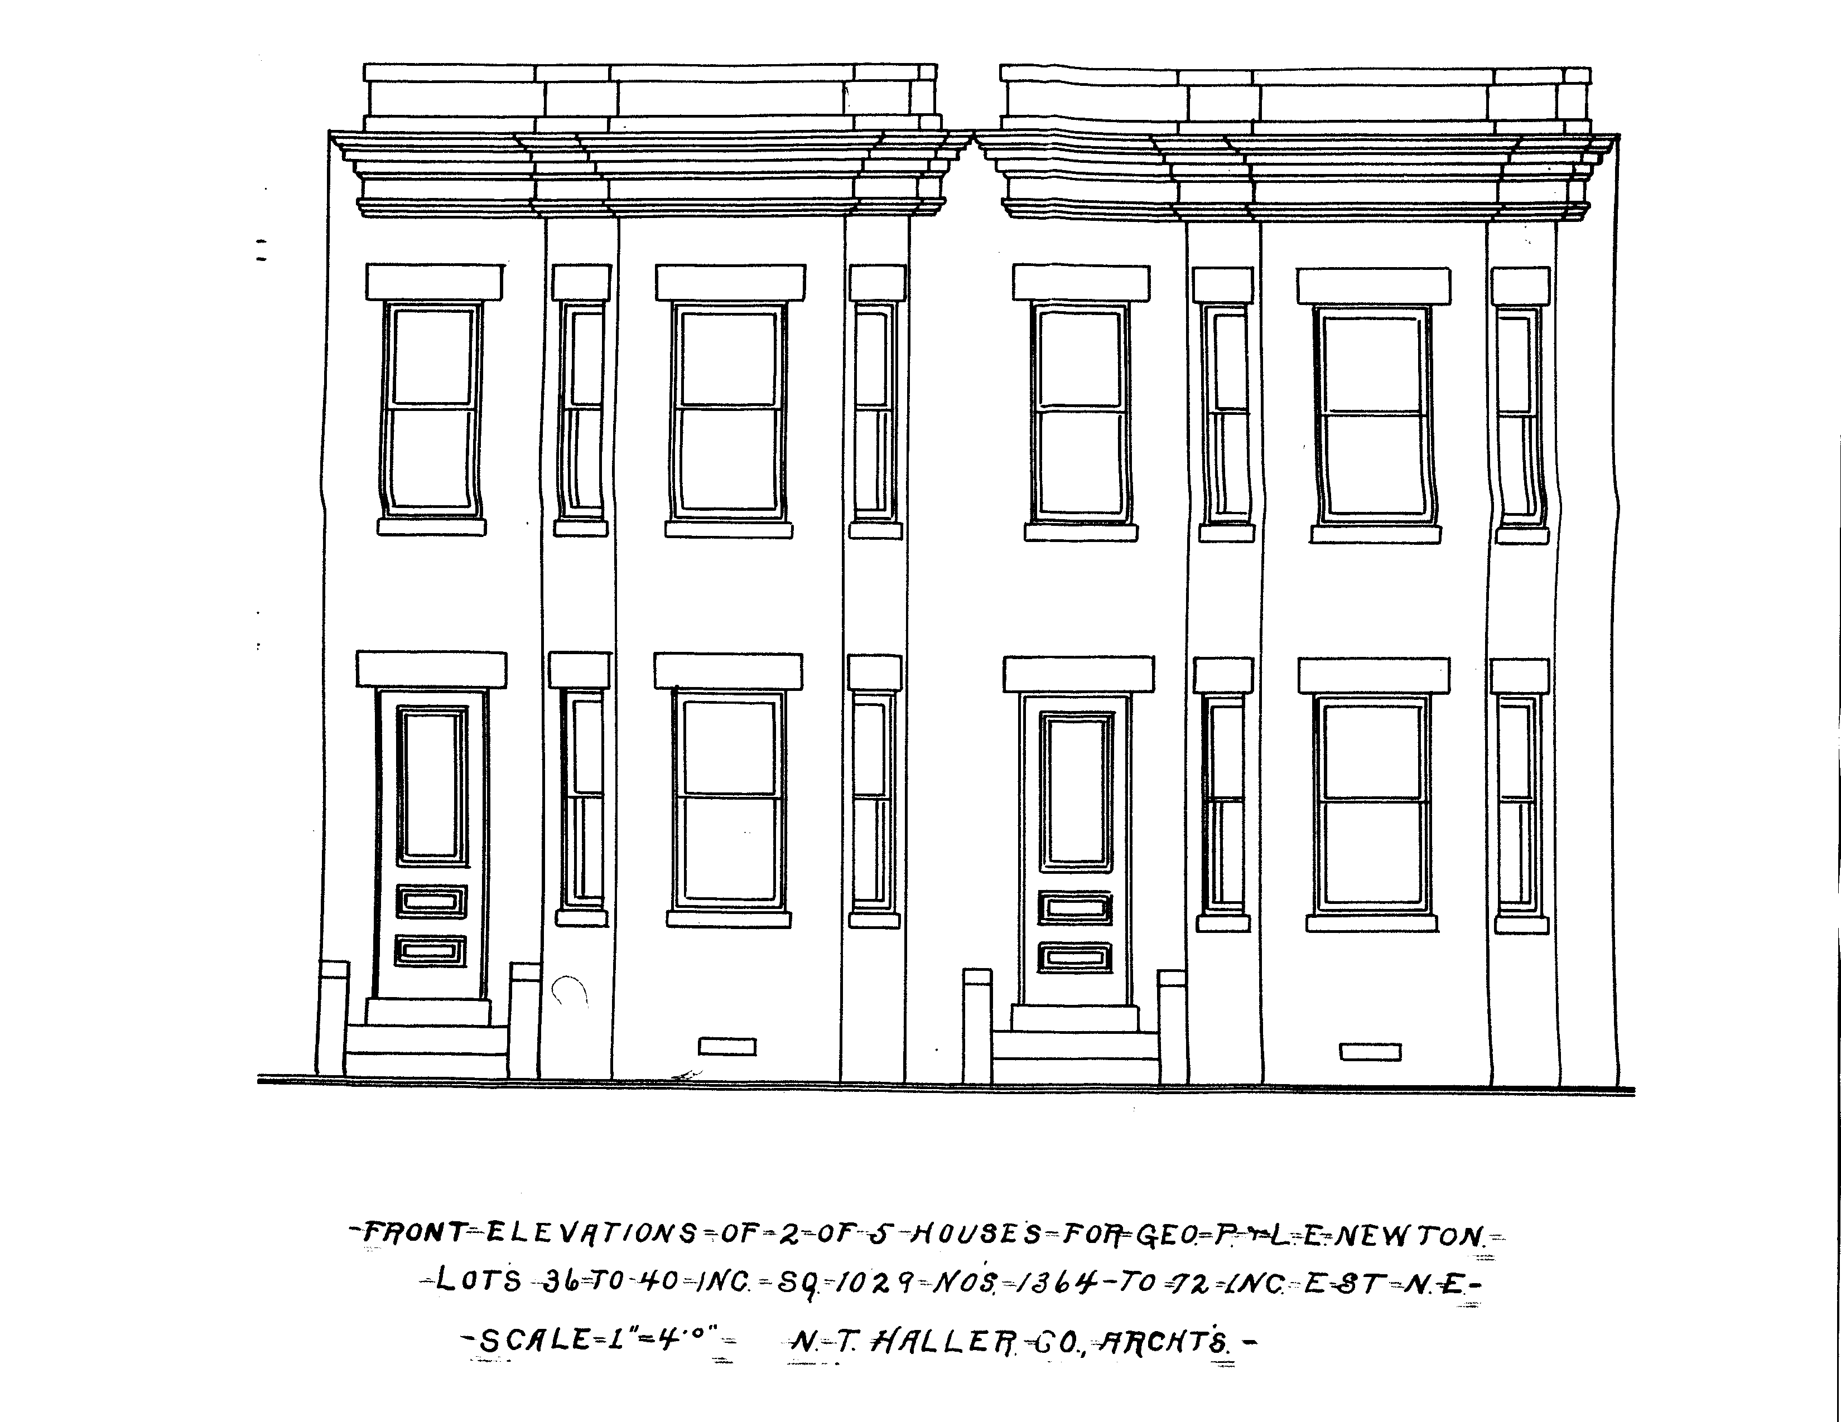 N.T. Haller's plans for George P. Newton's Classical Revival Houses at 1364-1372 E Street, NE (1905)

