1401 Pennsylvania Avenue, SE.
Built: 1986 (DC Assessments 2011)
Square: 1065, lot 142
Raze request approved: 2017

Original use: Pizza Hut restaurant

Uses by year, based on C&P Telephone Directory listings:
Year Use
1986- c. 2007 Pizza Hut
c. 2007-2017 New York Pizza

Dan and Frank Carney started the Pizza Hut chain in 1958 in Wichita, Kansas. Pizza Hut Pizza Hut's unmistakable double-pitch red roof was designed by Wichita architect Richard D. Burke (1929-1980) in 1969. This distinctive design was part of a trend in corporate architecture in the 1950s and 1960s transforming the building itself a corporate symbol. See McDonald's, Sonic, Howard Johnson. "Pizza Hut," wikipedia. Internet; accessed 2 Feb. 2016. Philip Langdon, Orange Roofs, Golden Arches: The Architectures of American Chain Restaurants (New York, N.Y.: Knopf, 1986). "Pizza Hut and the Legacy of Corporate Architecture," www.plantizen.com/node/66687. As of 1990 there were five Pizza Hut locations in Washington, including 1401 Pennsylvania Avenue, SE. C&P Telephone Directory.

A sign atop a pylon makes the restaurant visible to motorists from a distance, a technique used in Las Vegas. In their 1972 book on Las Vegas, Robert Venturi and Denise Scott Brown speak of a "new landscape of big spaces, high speeds, and complex programs. ... drivers rel[y] on signs for guidance-enormous signs in vast spaces at high speeds. " Robert Venturi, Denise Scott Brown, Steven Izenour, Learning from Las Vegas (Cambridge Mass.: MIT Press, 1972, revised 1977, 8-9). New York Pizza must have inherited this pylon sign from Pizza Hut, which regularly used these signs. As a result, for 30 years there was a highway-style sign on Pennsylvania Avenue, SE, speed limit 25 mph.
New York Pizza, 1401 Pennsylvania Avenue, SE, north elevation with pylon sign, looking southeast
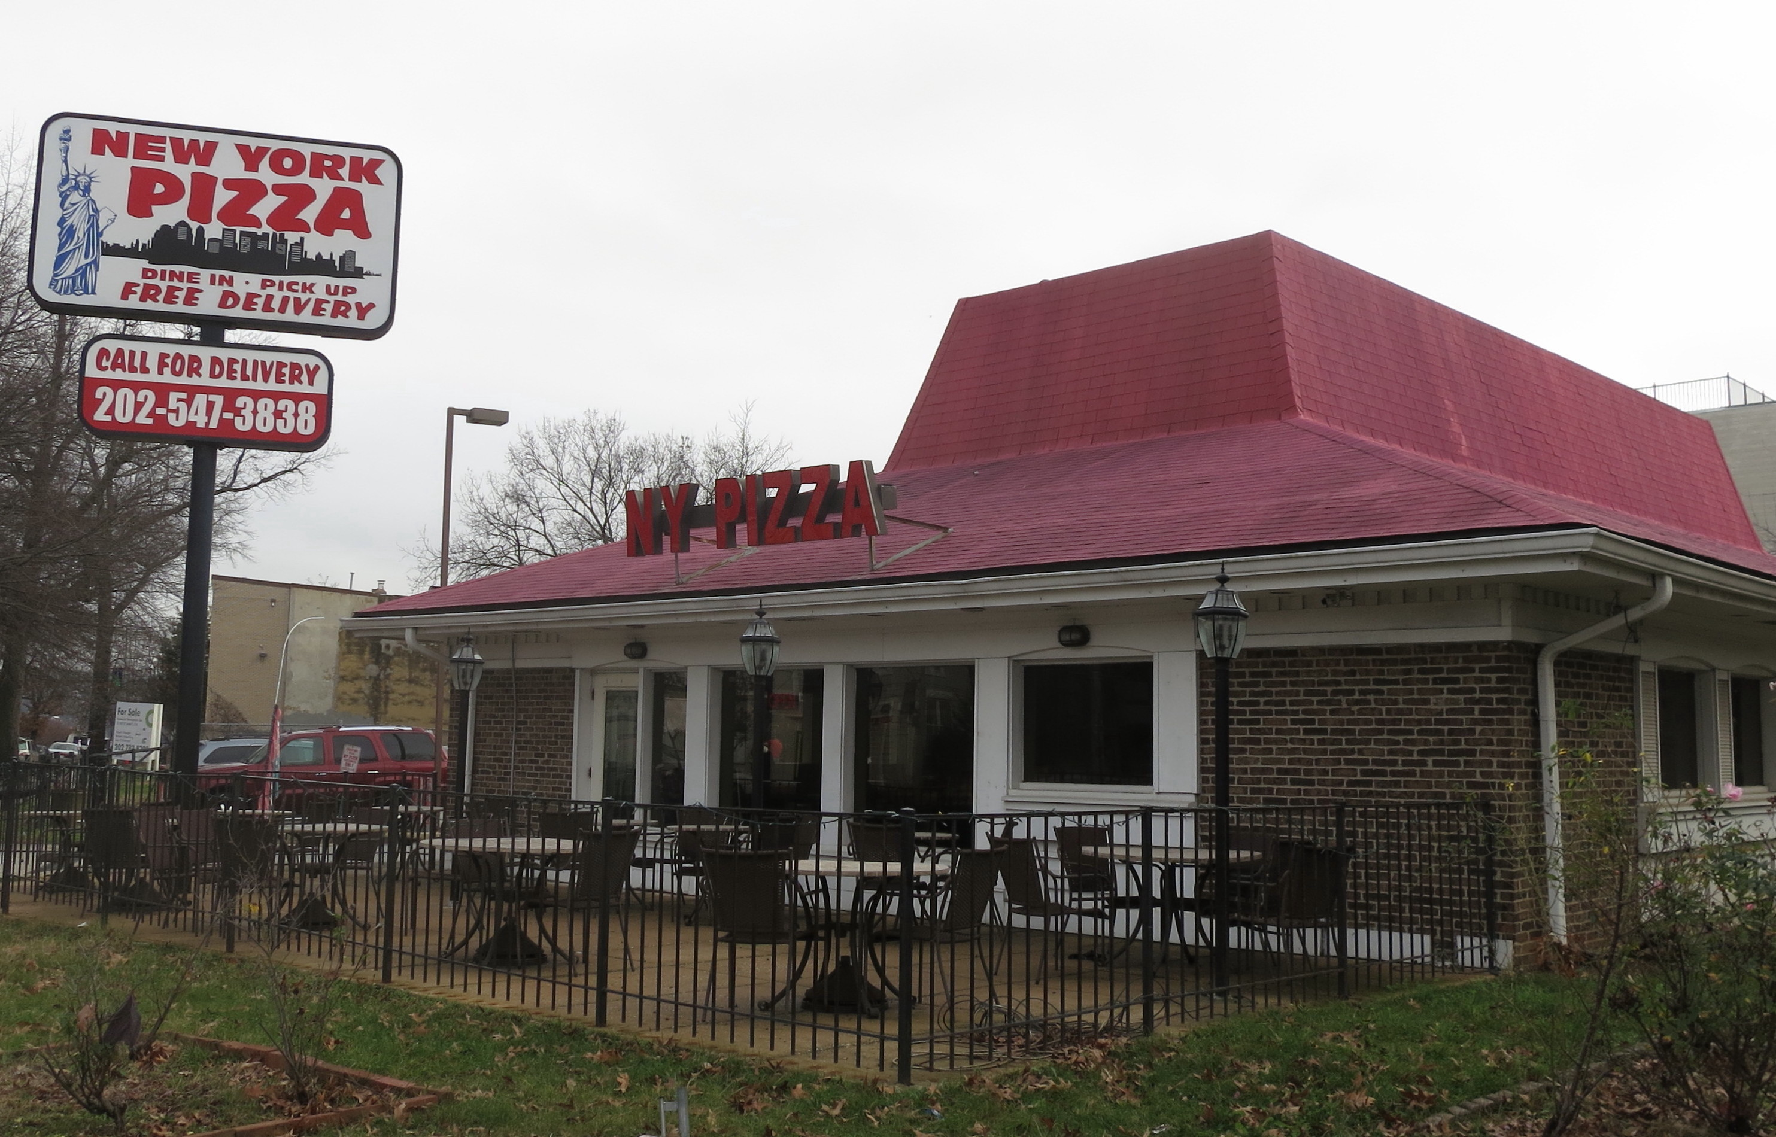

New York Pizza, 1401 Pennsylvania Avenue, SE, entrance and pylon sign, looking west

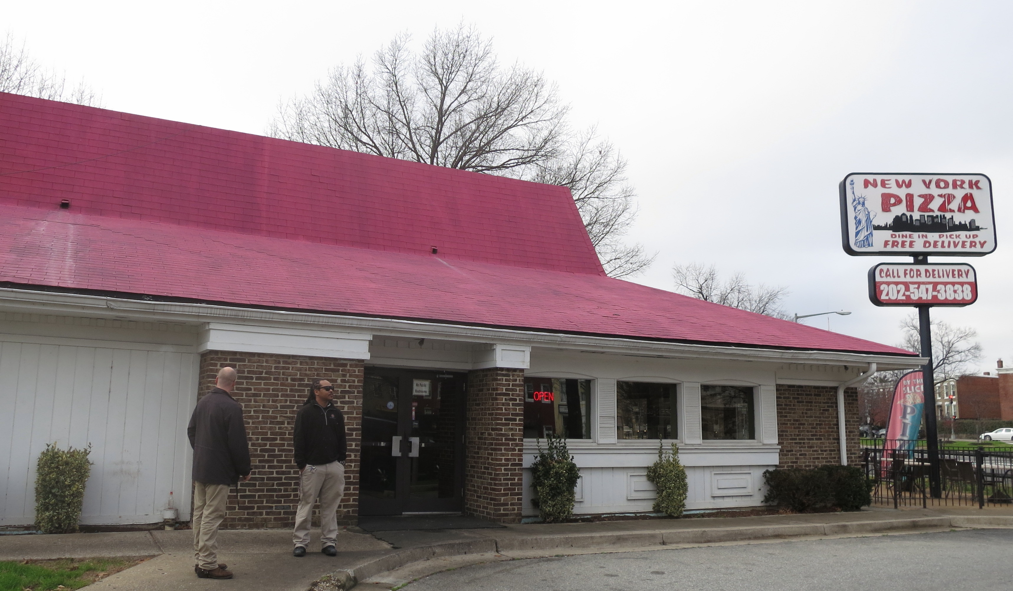

New York Pizza, 1401 Pennsylvania Avenue, SE, rear view

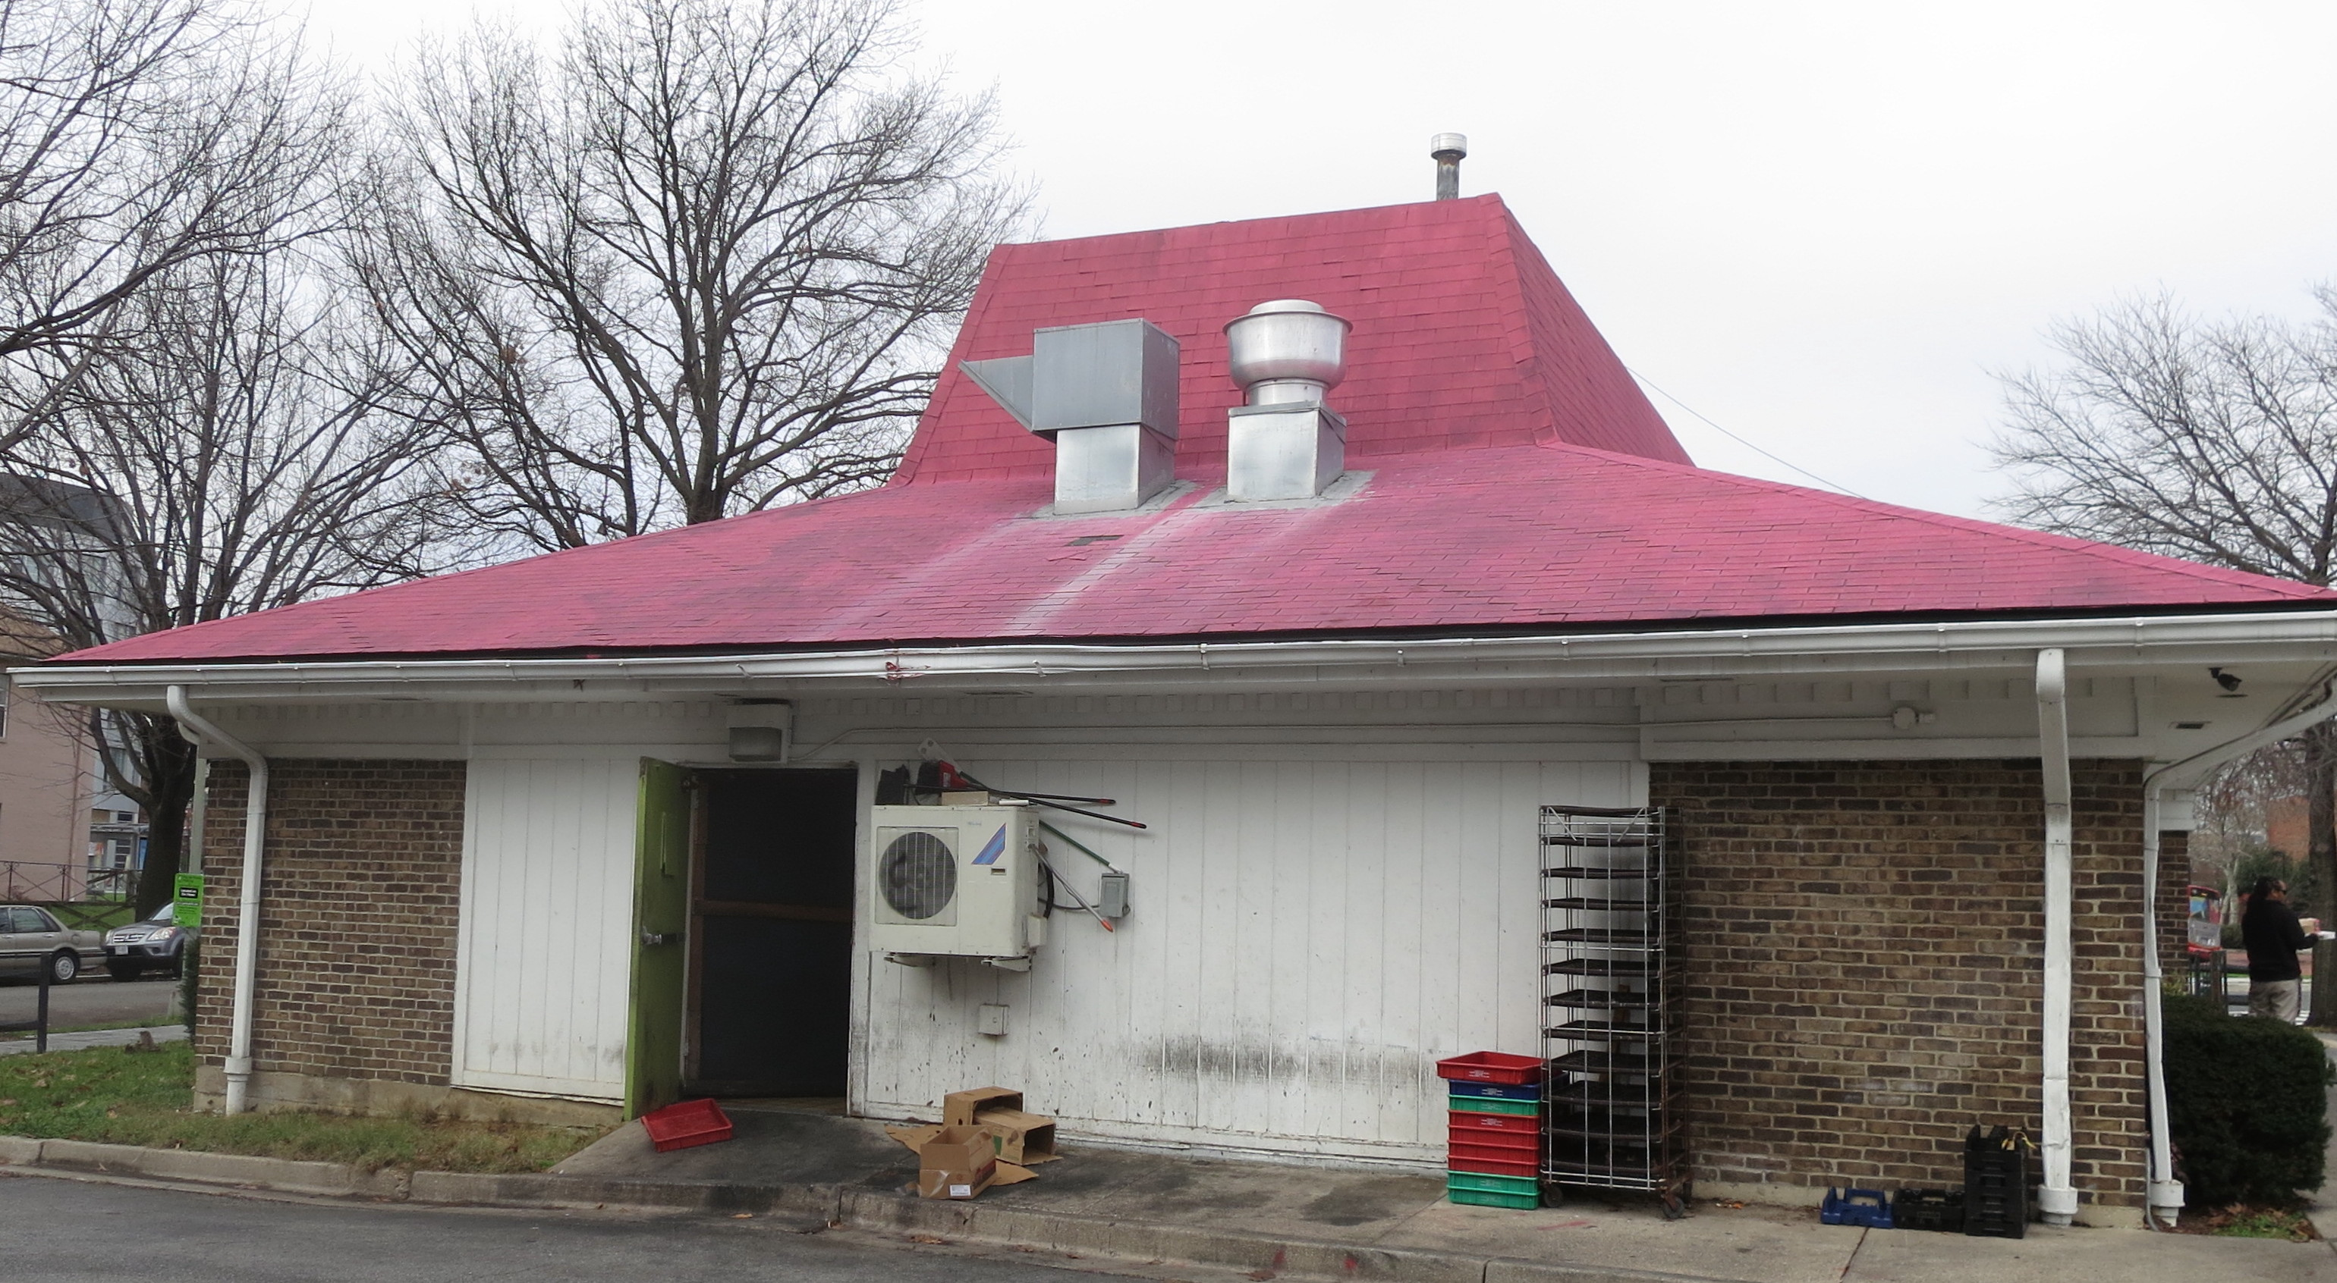

New York Pizza, 1401 Pennsylvania Avenue, SE, side view



