Free Guided Outdoor Mini-tour of Duddington Place, SE

May 12 & 13, 2018

This walking tour is free and open to everyone - a House & Garden Tour ticket is not needed.

Meet at the west end of Duddington Place, SE, on 1st Street between E and F streets, SE.
Tour schedule:
Saturday May 12: 5 pm
Sunday May 13: 2 pm & 4 pm
Outdoor tour only; no houses will be open
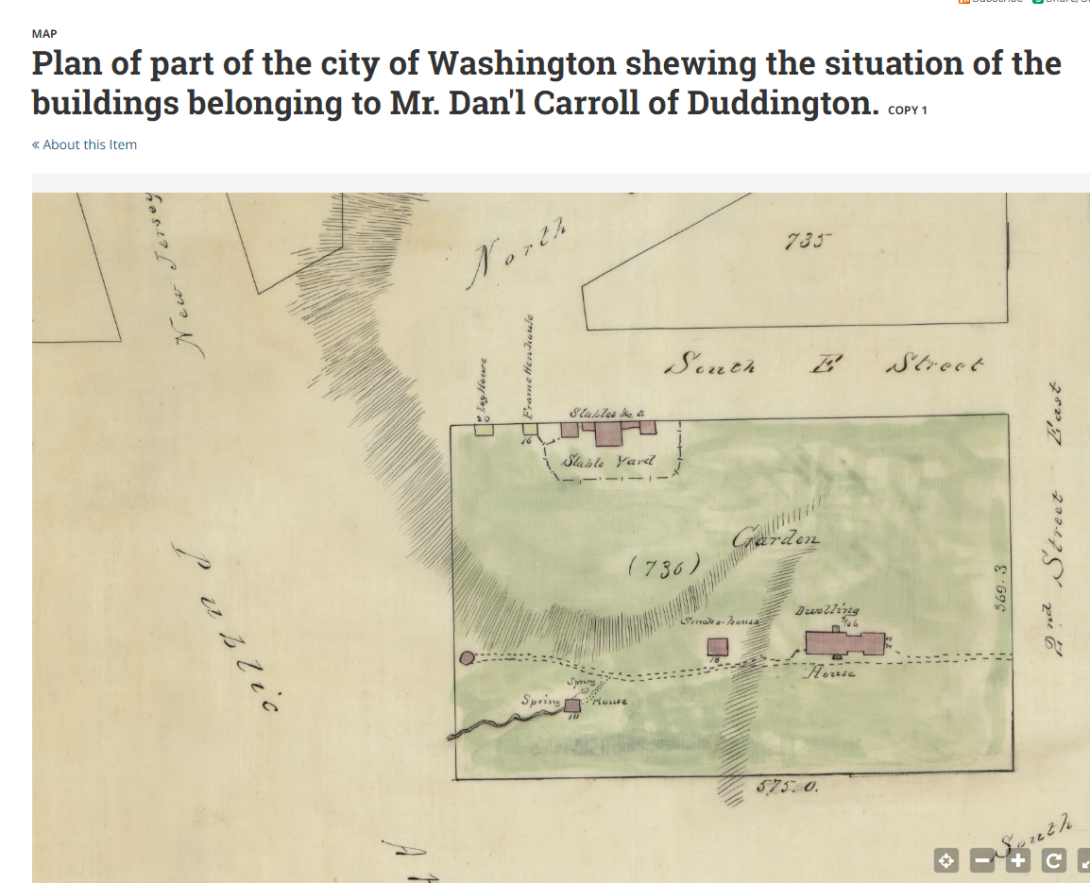

Nicholas King (1796). Square 736, bounded by 1st, 2nd, E and F streets. New Jersey Avenue is on the upper left.

Daniel Carroll's Duddington, square 736, view of driveway and front of the house, looking north from F Street, SE (c. 1880)

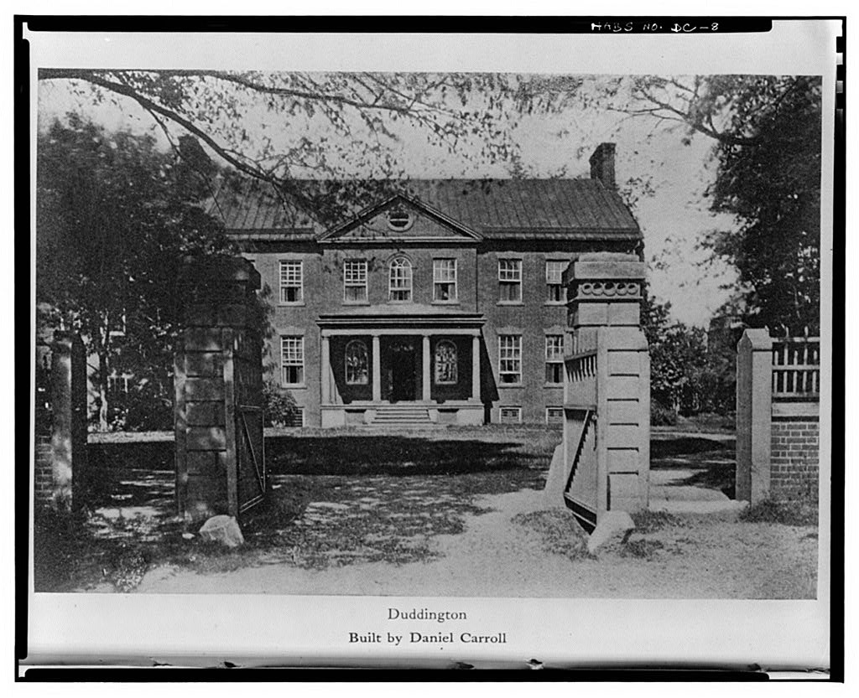

Repository: Library of Congress Prints and Photographs Division Washington, D.C. 20540 USA
Digital Id: cph 3c33773 //hdl.loc.gov/loc.pnp/cph.3c33773 cph 3c01595 //hdl.loc.gov/loc.pnp/cph.3c01595
Library of Congress Control Number: 90712251
Reproduction Number: LC-USZ62-133773 (b&w film copy neg.) LC-USZ62-101595 (b&w film copy neg. of cropped copy

Square 736 Hopkins Map (1893) showing 146 lots created by Heckman, Heckman Street, alleys, and Heckman's brick houses on lots 92-104.

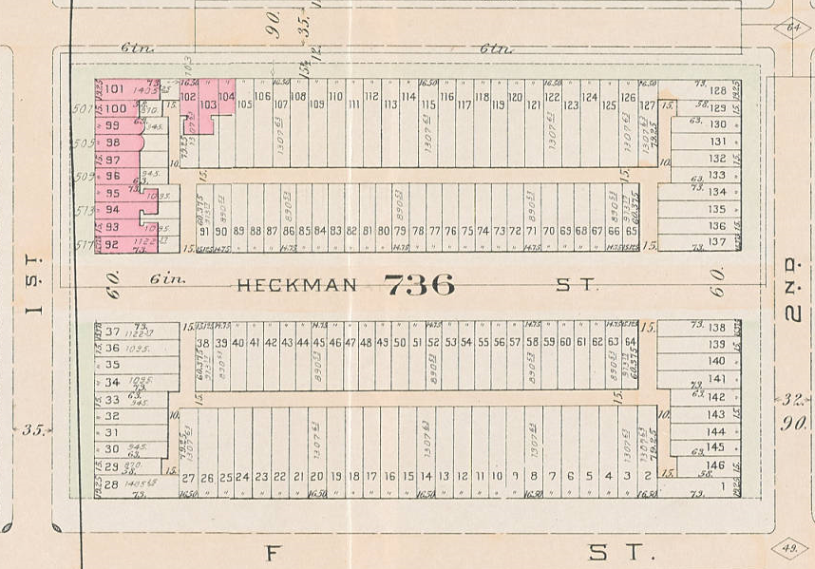

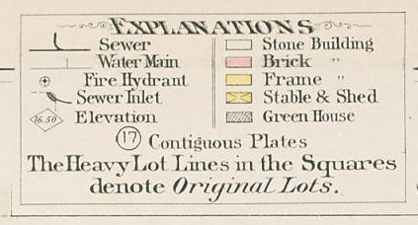
Development of Heckman Street (Duddington Place) 1890-1906
Address | Street (SE) | Lot # | Date | Owner | Architect | Builder | Building permit #
 |  |  |  |  |  |  | & comments
101 | Duddington Place | 37 | 1899 | Milton W. Plager | Wm. S. Plager | Milton W. Plager
110 | Duddington Place | 91 | 1906 | Thos. J. Pickford | WJ Simmons | n/a | # 1800 (22 Nov 1906)
111 | Duddington Place | 38 | 1897 | Jos. S. Meriwether | FW Carlisle | Jos. S. Meriwether | # 1430 (28 May 1897)  receiver appointed 1897
112 | Duddington Place | 90 | 1895 | MP Caldwell | Albert Goenner | MP Caldwell
113 | Duddington Place | 39 | 1897 | Jos. S. Meriwether | FW Carlisle | Jos. S. Meriwether | receiver appointed 1897
114 | Duddington Place | 89 | 1895 | MP Caldwell | Albert Goenner | MP Caldwell
115 | Duddington Place | 40 | 1897 | Jos. S. Meriwether | FW Carlisle | Jos. S. Meriwether | receiver appointed 1897
116 | Duddington Place | 88 | 1895 | MP Caldwell | Albert Goenner | MP Caldwell
117 | Duddington Place | 41 | 1897 | Jos. S. Meriwether | FW Carlisle | Jos. S. Meriwether | receiver appointed 1897
118 | Duddington Place | 87 | 1895 | MP Caldwell | Albert Goenner | MP Caldwell
119 | Duddington Place | 42 | 1897 | Jos. S. Meriwether | FW Carlisle | Jos. S. Meriwether | receiver appointed 1897
120 | Duddington Place | 86 | 1895 | MP Caldwell | Albert Goenner | MP Caldwell
121 | Duddington Place | 43 | 1897 | Jos. S. Meriwether | FW Carlisle | Jos. S. Meriwether | receiver appointed 1897
122 | Duddington Place | 85 | 1895 | MP Caldwell | Albert Goenner | MP Caldwell
123 | Duddington Place | 44 | 1897 | Jos. S. Meriwether | FW Carlisle | Jos. S. Meriwether | receiver appointed 1897
124 | Duddington Place | 84 | 1895 | MP Caldwell | Albert Goenner | MP Caldwell
125 | Duddington Place | 45 | 1897 | Jos. S. Meriwether | FW Carlisle | Jos. S. Meriwether | receiver appointed 1897
126 | Duddington Place | 83 | 1895 | MP Caldwell | Albert Goenner | MP Caldwell
127 | Duddington Place | 46 | 1897 | Jos. S. Meriwether | FW Carlisle | Jos. S. Meriwether | receiver appointed 1897
128 | Duddington Place | 82 | 1895 | MP Caldwell | Albert Goenner | MP Caldwell
129 | Duddington Place | 47 | 1897 | Jos. S. Meriwether | FW Carlisle | Jos. S. Meriwether | receiver appointed 1897
130 | Duddington Place | 81 | 1895 | MP Caldwell | Albert Goenner | MP Caldwell
131 | Duddington Place | 48 | 1897 | Jos. S. Meriwether | FW Carlisle | Jos. S. Meriwether | receiver appointed 1897
132 | Duddington Place | 80 | 1895 | MP Caldwell | Albert Goenner | MP Caldwell
133 | Duddington Place | 49 | 1897 | Jos. S. Meriwether | FW Carlisle | Jos. S. Meriwether | receiver appointed 1897
134 | Duddington Place | 79 | 1895 | MP Caldwell | Albert Goenner | MP Caldwell
135 | Duddington Place | 50 | 1897 | Jos. S. Meriwether | FW Carlisle | Jos. S. Meriwether | receiver appointed 1897
136 | Duddington Place | 78 | 1895 | MP Caldwell | Albert Goenner | MP Caldwell
137 | Duddington Place | 51 | 1897 | Jos. S. Meriwether | FW Carlisle | Jos. S. Meriwether | receiver appointed 1897
138 | Duddington Place | 77 | 1895 | MP Caldwell | Albert Goenner | MP Caldwell
139 | Duddington Place | 52 | 1897 | Jos. S. Meriwether | FW Carlisle | Jos. S. Meriwether | receiver appointed 1897
140 | Duddington Place | 76 | 1895 | MP Caldwell | Albert Goenner | MP Caldwell
141 | Duddington Place | 53 | 1897 | Jos. S. Meriwether | FW Carlisle | Jos. S. Meriwether | receiver appointed 1897
142 | Duddington Place | 75 | 1895 | MP Caldwell | Albert Goenner | MP Caldwell
143 | Duddington Place | 54 | 1897 | Jos. S. Meriwether | FW Carlisle | Jos. S. Meriwether | receiver appointed 1897
144 | Duddington Place | 74 | 1895 | MP Caldwell | Albert Goenner | MP Caldwell
145 | Duddington Place | 55 | 1897 | Jos. S. Meriwether | FW Carlisle | Jos. S. Meriwether | receiver appointed 1897
146 | Duddington Place | 73 | 1896 | MP Caldwell | Albert Goenner | MP Caldwell
147 | Duddington Place | 56 | 1897 | Jos. S. Meriwether | FW Carlisle | Jos. S. Meriwether | receiver appointed 1897
148 | Duddington Place | 72 | 1896 | MP Caldwell | Albert Goenner | MP Caldwell
149 | Duddington Place | 57 | 1897 | Jos. S. Meriwether | FW Carlisle | Jos. S. Meriwether | receiver appointed 1897
150 | Duddington Place | 71 | 1896 | MP Caldwell | Albert Goenner | MP Caldwell
151 | Duddington Place | 58 | 1897 | Jos. S. Meriwether | FW Carlisle | Jos. S. Meriwether | receiver appointed 1897
152 | Duddington Place | 70 | 1896 | MP Caldwell | Albert Goenner | MP Caldwell
153 | Duddington Place | 59 | 1897 | Jos. S. Meriwether | FW Carlisle | Jos. S. Meriwether | receiver appointed 1897
154 | Duddington Place | 69 | 1896 | MP Caldwell | Albert Goenner | MP Caldwell
155 | Duddington Place | 60 | 1897 | Jos. S. Meriwether | FW Carlisle | Jos. S. Meriwether | receiver appointed 1897
156 | Duddington Place | 68 | 1896 | MP Caldwell | Albert Goenner | MP Caldwell
157 | Duddington Place | 61 | 1897 | Jos. S. Meriwether | FW Carlisle | Jos. S. Meriwether | receiver appointed 1897
158 | Duddington Place | 67 | 1896 | MP Caldwell | Albert Goenner | MP Caldwell
159 | Duddington Place | 62 | 1897 | Jos. S. Meriwether | FW Carlisle | Jos. S. Meriwether | receiver appointed 1897
160 | Duddington Place | 66 | 1896 | MP Caldwell | Albert Goenner | MP Caldwell
161 | Duddington Place | 63 | 1897 | Jos. S. Meriwether | FW Carlisle | Jos. S. Meriwether | receiver appointed 1897
162 | Duddington Place | 65 | 1896 | MP Caldwell | Albert Goenner | MP Caldwell | # 1005 (16 Jan. 1896)
163 | Duddington Place | 64 | 1897 | Jos. S. Meriwether | FW Carlisle | Jos. S. Meriwether | receiver appointed 1897
170 | Duddington Place | 137 | 1895 | Brooks Cason | B. S. Simmons | CJ Hanbeck

History of square 736

Duddington Place in square 736 has played a role in Washington' s history from an early date. Daniel Carroll of Duddington, one of the city's original landowners, known for his dispute with L'Enfant on siting his house in the middle of nearby New Jersey Avenue, rebuilt his mansion and outbuildings there. The Carroll family owned the land until 1886, when a syndicate purchased the square for $55,000. The mansion was demolished, and the grounds were partially regraded to prepare for development.
In 1890, Archimedes Heckman (1810-1892), a wealthy Philadelphia speculator, bought all of square 736. Heckman subdivided the square for development by creating 146 rowhouse lots, and created a new street, Heckman Street, running east to west across the square. Because lots fronting on main streets had a higher per-square foot value, to maximize profit, Heckman made the lots fronting on 1st, 2nd, E and F streets larger than the lots fronting on Heckman Street (890 vs. 1307 square feet). Heckman planned to build out the entire square himself, and engaged architect George B. Phelps to plan for eight or ten groups of houses, each with a "distinct architectural effect" part of a "harmonious whole." In 1890, Heckman began building houses on 1st Street and E streets (as shown on the 1893 Hopkins map). Heckman promised special Philadelphia features in his houses: Interiors would have natural hardwoods; bedrooms would have two stationary wardrobes separated by a marble washstand covering the entire side of a room; and heat the houses with portable heaters instead of latrobes. Heckman died before he could finish building out the square.
In March 1893, Deeble and Davis purchased square 736 for $140,000 and two days later advertised the square (including the improved lots with rental houses) for $175,000, touting nearby Garfield Park and the Anacostia streetcar line (passing the Center Market, Boston Store, Palais Royal department store, and the Pennsylvania Railroad depot (6th and B streets, NW)). In 1894, the price was reduced to $100,000. In March 1896, a bill was introduced in Congress to purchase the southern half of square 736 for $152,000 to build the government printing office; nothing came of the proposal, and developers continued to build houses. In May 1897, James H. Meriwether began to build # 111 - 163 Duddington Place. He must have run into financial problems because in December 1897, his lender had a receiver appointed, who sold off the houses in bulk to investors. The depression of 1893, which lasted until approximately 1897, may have contributed to Meriwether's problems.

Queen Anne houses for working class tenants

Judith Capen, AIA describes Queen Anne style as "... variety in pressed brick, and as belt and string coursing ... brick door and window hoods. To enliven the roof line, row houses acquired large and elaborate roof cornices." Houses on Duddington Place express the Queen Anne style in a simpler way through dentils and pediments at the cornice, shallow bays, string courses as window sills, and window openings surmounted by brick segmental arches.
By 1900, the first census after most houses were built, Duddington Place was home to men who worked on the railroad, and at the Washington Navy Yard, and Government Printing Office; others worked in the construction trades. The street was 100% white, and 90% of families were renting. In 1910, all residents were white, except for Rosie Winkfield, who worked as a live-in servant for the Ashby family at # 150. All but one family was renting. In 1920, 76% of households were African-American, and 74% of all households were renting. African-American residents worked as laborers (men) or car cleaners (women) for the railroad, men worked at the Washington Navy Yard, and as drivers, elevator operators, and waiters; some women worked as domestics or did laundry at home. In 1930 and 1940, all families were African-American, except for immigrant families, one at # 153, and the store-keepers at # 162 (1930 and 1940) and 164 (1930 only). In 1930, 68% were renting, and in 1940, 73% were renting. In 1930 and 1940, residents continued to work at similar occupations, but in 1940 one black resident was a policeman and women no longer worked as laundresses.
Before fair housing laws, owners sometimes advertised houses for sale or rent specifically to either blacks or whites. In 1921, an African-American couple, Mr. and Mrs. Ford, responded to a newspaper ad offering 125 Heckman Place for sale to colored buyers for $2,575 and purchased the house.
In 1970, Mrs. Bertha Jones, 115 Duddington Place, a longtime resident, told a reporter that the first white family moved to the street in 1960, to 112 Duddington Place. She said the even-numbered houses were mostly rental, and that black homeowners lived on the odd-numbered side. Mr. Diggs, 141 Duddington Place, another longtime resident, remembered that the street was once a "haven for illegal liquor, gambling and women."

Corner stores
Duddington Place had corner grocery store at # 162 between 1900 and 1954. In 1919, Samuel A. Golden operated the store; he was a spokesman for Corby's Mothers Bread: "The quality of Corby's Mothers Bread never changes, so far as I can see, except to get better ... ." In the early 20th century, the Corby Bakery, founded c. 1890, was one of the three largest bakeries in the city. Charles and William Corby expanded their bakery on the 2300 block of Georgia Avenue, NW in 1902 and 1912. Continental Baking Co. bought the bakery in 1925, and replaced Mothers Bread with Wonder Bread. The LoBuono family operated a store at # 164 as of 1930.

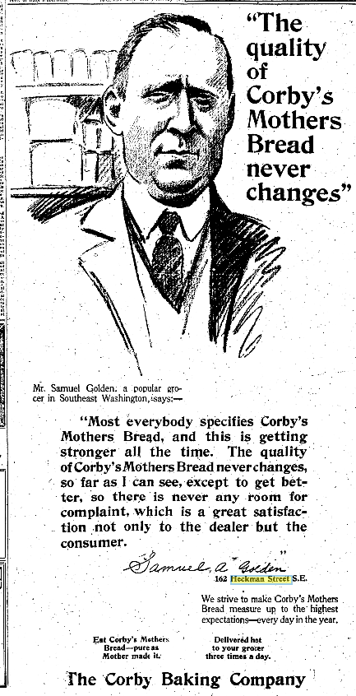

Colonial Revival and renovation on Duddington Place in 1960s

Many historians believe that Americans sought, and still seek, a distinctive national "American" style, and that buildings from the Colonial era, interpreted in each decade, fill this need. "Revivals" of colonial houses began in the early 19th century, and gained momentum from the world's fair in Chicago in 1893 (World's Columbian Exposition), where millions of people saw states' pavilions featuring adaptations of Colonial houses (e.g., John Hancock's house in Boston, the tower of Independence Hall in Philadelphia). Sears Roebuck's kit houses, in addition to the bungalows, included many popular "Colonial" designs such as "The Adams" and "The Martha Washington." Colonial Williamsburg opened in 1932 and further boosted interest in colonial architecture. Colonial Revival has remained popular ever since; its association with George Washington and other founders is a powerful cultural force, and Americans continue to respond. Donald H. Drayer, a successful Washington architect, understood the Colonial Revival style and used its elements in many of his projects.
In the early 1960s developers bought 30 Duddington Place houses for renovation and resale. They hired "society architect" Drayer, known for his historic preservation projects, to design the houses. They gutted the interiors, keeping only the floors and walls; inside, on the first floor was a kitchen in front, utility room and powder room, and upstairs, two bedrooms. Drayer designed a Colonial Revival look for the front: enlarging the entranceways, adding swans neck pediments, changing the window openings, adding six-over-six windows, shutters, and brick steps. Elmer Klavens handled the renovations. 114 Duddington Street was a model house.

Architects

Donald H. Drayer (1909-1973) (renovation design for 114, etc. Duddington Place) In his long career, Drayer, a "society architect," designed large apartment buildings (Grosvenor Park, Rockville, Md.; Prospect House, Arlington, Va.; Colonade, Washington, DC), large residential developments (Chatsworth, Chevy Chase) and many individual residential projects for well-known clients including Lyndon Johnson. Drayer was noted for his historic preservation projects.

Albert Goenner (1860-1918) (112-162 Duddington Place, 1896). Goenner was born and educated in Germany, and came to Washington c. 1880. He designed many apartments and commercial buildings, and several houses.

George B. Phelps (1857- ?) (502-518 1st Street, 101-109 E Street, 1890). Phelps appears to have been a very successful architect who designed high-end residences and stores.

William S. Plager (1860- active through 1937) (101 Duddington Place, 1899). Plager started as a builder and moved on to architecture, designing apartment buildings, rowhouses and theaters. His work on Capitol Hill includes the rowhouses in Square 1064 (G/15th/Potomac Avenue, SE, 1901); The Rita, 400 Seward Square SE (1905); an apartment building, 226 Kentucky Avenue, SE (1915); and the Home Theater, 1230 C Street, NE (1916).

B. Stanley Simmons (1872-1931) (170 Duddington Place, 1895). Simmons was one of the most prolific architects in Washington, and worked with every major developer, including Harry Wardman and Lester Barr. He designed more than 60 apartment buildings between 1890 and 1926, including The Wyoming (2022 Columbia Road, NW, for Barr (1911) considered by some to be his masterpiece), the Embassy (1613 Harvard Street, NW, (1924)) and the Highview (2505 13th Street, NW (1925)) for Herman R. Howenstein. He also designed the National Metropolitan Bank, 613 15th Street, NW (1905), the Northeast Savings Bank, 800 H Street, NE (1921); the Barr Building at Farragut Square (1929); the Elks Club, 919 H Street, NW (1908, demolished); and the Fairfax Hotel, 21st and Massachusetts Avenue, NW (1921). Simmons designed and built rowhouses in the 1890s, before he moved on to bigger commissions.

Other resources

- chrs.org/duddington-place-walking-tour/ Walking tour handout; Demographic notes from newspaper articles; 1900 & 1920 census; owners, architects and builders in square 736

- Capitol Hill History Project. Maps and biographies of early landowners. www.capitolhillhistory.org/lectures/vlach/index/html. John Vlach, April 8, 2003 Overbeck History Lecture, "Capitol Hill Before L'Enfant"

- Oral history: Shirley Womack, who lived at 129 Duddington Place. 11 Nov. 2011. www.capitolhillhistory.org

- Census records: www.archives.gov/research/census or www.stevemorse.org (input DC, census date, and enumeration district (ED)). For Duddington Place: 1900 (ED 134); 1910 (ED 84); 1920 (ED 102); 1930 (ED 118 ); 1940 (ED 181)

- Elizabeth Clark-Lewis, Living In, Living Out: African American Domestics in Washington, D.C., 1910-1940 (Washington, DC: Smithsonian Institution, 1994)

www.chrs.org 202 543-0425

"Real Estate Gossip," Washington Star, 26 July 1890, 15.
The name Heckman Street was changed to Duddington Place in 1961. DC Office of Surveyor, 141/12 (9 Feb. 1961). "Official Notices," Washington Star, 5 Jan. 1961, 53.
"Real Estate Gossip," Washington Star, 26 July 1890, 15. "City and District," Washington Star, 26 July 1890, 15. "The Latrobe Stove, also known as a 'Baltimore Heater,' was a coal-fired parlor heater made of cast iron and fitted into fireplaces as an insert ... and [was] very popular by the 1870s. "Latrobe Stove," wikipedia. Internet; accessed 7 Apr. 2018.
Return of Death in City of Philadelphia (10 June 1892).
"Real Estate Matters," Washington Star, 16 Mar. 1893, 9. Advertisement, Washington Star, 18 Mar. 1893, 9. Washington Star, 22 Mar. 1893, 3. Washington Star, 29 Jan. 1894, 2.
"Sensational Scene," Washington Star, 31 Mar. 1896, 1.
Building permit # 1430 (28 May 1897). "Receiver Asked For," Washington Star, 16 Dec. 1897, 15. "Under the hammer," Washington Star, 30 Jan. 1897, 3. "Sales of Real Estate," Washington Star, 23 July 1898, 13.
The 1893 depression was caused by a decline in commodity prices and railroad failures, leading to a run on banks and a decline in stock prices. Nationwide, 500 banks closed, 15,000 businesses failed, and unemployment reached 12%. The depression reduced the demand for new buildings in DC (as reflected in a decline in building permits) "Panic of 1893," wikipedia. Internet; accessed 6 Apr. 2018. Constance McLaughlin Green, Washington, Capital City: vol. II (Princeton, N.J.: Princeton University Press, 1963, 16-17).
Judith Capen, AIA, Building Styles in the Capitol Hill Historic District, 8, Capitol Hill Restoration Society (1991).
US Census: 1900 (ED 134), 1910 (ED 84), 1920 (ED 102), 1930 (ED 118), 1940 (ED 181).
Advertisement, Washington Star, 10 June 1916, 17: "Fine opportunity for good colored tenant to rent modern house in Heckman street southeast for $16.50: six rooms and bathroom; brick." Advertisement for 125 Duddington Place, Washington Star, 27 July 1921, 29. Rec. Deeds 192110200053. US Census (1930, ED 118). Advertisement: sale or trade to colored, 122 Heckman Street, Washington Star, 23 June 1957, 48.
John Sherwood, "Duddington Place: A Block with No Bloc," Washington Star, 27 July 1970, B1. The 1940 census shows 22 African-American homeowners and 16 renters on the odd numbered side and six owners and 27 renters on the even-numbered side.
Craig Herndon, "Food and Games," Washington Post, 10 June 1974, sec. B, p. 3.
Advertisement, Washington Star, 15 Mar. 1919, 3. "Washington's Best Thing Since Before Sliced Bread," blogs.weta.org/boundarystones. Internet; accessed 7 Feb. 2018.
John B. Willmann, "Capitol Hill Area Lures 'City Folks'," Washington Post, 8 Oct. 1960, sec. C, p. 1. Advertisement, Washington Star, 15 Oct. 1960, 34. The developers were: E. Fulton Brylawski, John H. Safer, Samuel Moerman, and Melvin Berman. Advertisement, Washington Star, 15 Oct. 1960, 34. In 1960 Drayer prepared plans for several houses nearby (records are in Library of Congress Prints & Photographs Division): 140 D Street, SE, Call Number: ADE - UNIT 1184 121 E Street, SE, Call Number: ADE - UNIT 1201 110 F Street, SE, Call Number: ADE - UNIT 1202 124 F Street, SE, Call Number: ADE - UNIT 1203
"Donald Drayer, Area Architect," Washington Star, 24 Apr. 1973, 54. "Chatsworth," Washington Star, 13 Sept. 1974, 105. www.loc.gov > prints & photographs > "donald drayer".
Allan B. Slauson, A History of Washington, its men and institutions (Washington, DC: Washington Post, 1903), quoted in www.washingtonhistory.com/surveys/Shawreport final (2008).
"Three Handsome Houses," Washington Post, 18 Sept. 1887, 2. "Some New City Houses," Washington Post, 10 June 1888, 5.
Pamela Scott, A Directory of District of Columbia Architects: 1822-1960, (1999, 154.) DC Historic Preservation Office, Inventory of Historic Sites.

